|  |
| --- |
| Functional Design Document |
| CHG213528: |
| TMEC - MD – Product Harmonization V2 |
| Markets: Global |
| Release: RLS000734 (Jun’22) |



Contents

A. Document approval 3

B. Revision history 3

1. Business Process Overview 4

1.1 Process Overview 4

1.2 Impact Matrix 4

2. Description of the functional change 5

2.1 Changes in Siebel Sales 5

2.2 English Captions 8

2.3 Changes in the ETL 8

2.3.1 Initial Loads/Massive Data updates 9

2.3.2 Performance test/Indexes creation 9

2.4 Changes in OBI 9

2.5 Data Dictionary 10

2.6 Changes in Data Interfaces 11

2.6.1 Inbound 11

2.6.2 Outbound 14

2.6.3. Initial Loads 14

2.6.4 Performance test / Indexes creation 14

2.7 Changes in Batch Processes / Aggregations / DRP 14

2.8 Use Case 14

# Document approval

*List members from market, DBU, BTS, ODC, GTC and other teams that are accountable and responsible for the CHG implementation. Add extra rows if required to include extra team members (e.g., responsible for different areas or services).*

|  |  |  |
| --- | --- | --- |
| Role | Name | Function |
| **Market Sponsor** | Phil Guilfoyle | TME Manager UK |
| **DBU Approver** | Nikita Ryzhkovich | Digital Customer Experience |
| **BTS expert** | Alexander Polyakov | BTS TME Manager |
| **ODC expert** | David Gallego | ODC Sales |
| **ODC expert** | Fran / Migual Lopez | ODC Data |
| **GTC expert** | Jose Carlos Martin | TME Tech Arch Mgr |

This is to confirm that we have reviewed the functional specifications for the proposed solution. We agree with its contents and understand that the technical specifications will be designed based on this approved document.

# Revision history

|  |  |  |  |  |
| --- | --- | --- | --- | --- |
| Revision | Section(s) | Description | Editor | Date |
| 1.0 | - | Draft | Marta Nuño | 02/03/22 |
| 1.1 | 2.1 Changes in Siebel Sales | Activation of Feb’22 release implemenation of product harmonization for V2 and V3 Markets | Sahima Murguia | 14/03/22 |
| 1.2 | 2.1.1 | Update changes related to UOM in order to activate functionality from previous CHG as well to V2/V3 (IE; KZ and cluster, RU) markets.  Provide detail of markets impacted.  Add comment related to “Product Form Applet” to apply same changes as in “JTI Product Form Applet”: | Marta Nuño | 17/03/2022 |
| 2.0 |  |  |  |  |
| 2.1 |  |  |  |  |
|  |  |  |  |  |
|  |  |  |  |  |
|  |  |  |  |  |

# Business Process Overview

## Process Overview

*Provide brief and meaningful information about the requested change, explain current situation, and estimated future improvements. Use Description, Benefits and Impact provide by market in the CHG.*

With the implementation of TME Connect Reset we want to achieve standardization of the processes, for which assessment of attributes Markets usage has been performed, and so identified those attributes considered part of the Global definition.

This standardization provides the baseline of those attributes required in the BI solution, as well as those that could be used in the new Mobile App.

With this CHG there are additional attributes to be included due to the wave V2 functionality. They must be included as well on the Siebel layouts and in the product inbound interface.

Objective of this CHG is to get the changes applicable for the markets only when each market is rolled to TME Connect Reset. Rest of markets must remain without any impact and working as usually.

## Impact Matrix

|  |  |
| --- | --- |
| GRM Functionality | Product |
| Impact Current Functionality? | Yes |
| Markets Affected | All |
| Applications Affected | Sales / Data |
| Risk of Implementing the change | Medium |

# Description of the functional change

## Changes in Siebel Sales

*Explain required changes in Siebel Sales application. Provide names of the views, applets, fields, buttons, etc. Provide screenshots and wireframes of the estimated location for new object or in case of location change.*

Product standardization done during Feb’22 Release should be activated for V2 (Ireland) and V3 Markets (Russia, Kazakhstan + CAM cluster). So that the Markets have the same baseline. For further details please refer to [CHG213664](https://jti.service-now.com/nav_to.do?uri=change_request.do%3Fsys_id=a4833c871b997450e5ac9825bb4bcb74%26sysparm_stack=change_request_list.do%3Fsysparm_query=active=true):**TMEC: MD - Product**.

Next tables contain the list of new attributes to be created for Product entity.

|  |  |  |  |  |
| --- | --- | --- | --- | --- |
| **BC** | **Table** | **Field** | **Column** | **Type** |
| Internal Product – ISS Admin | S_PROD_INT | JTI Returnable Since | X_RETURN_STRT_DT | Date |
| JTI Returnable Until | X_RETURN_END_DT | Date |

Please, at the existing list applet, include the attributes listed in the table. They have to be available for selection at the “Columns Displayed” functionality:

Screen: ISS Unified Administration Screen

View: ISS Product Administration View

Business Object: Admin ISS Product Definition

Applets: **JTI SIS Product List Admin Applet**

Business Components: Internal Product - ISS Admin

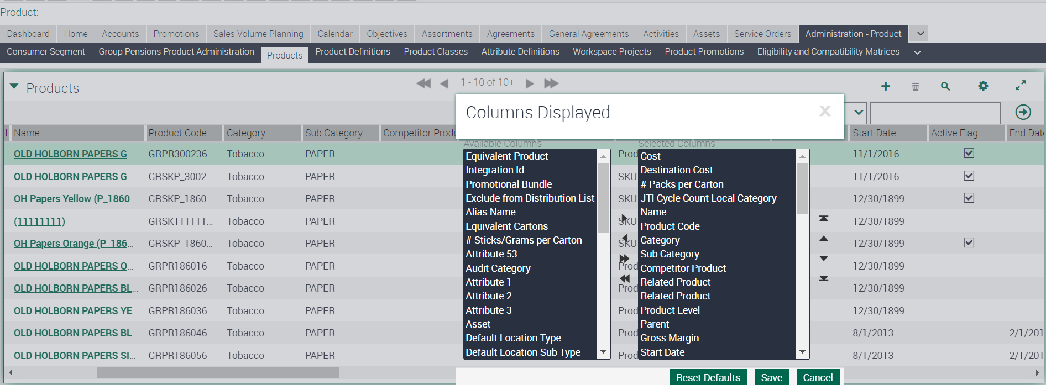

See table with the attributes included in the applet. This will impact markets in V1(IT, ES, CZ, SK, HU) ,V2 and V3 and V3 (IE, KZ and cluster,RU).

| **Attribute** | **Display Value** | **Table** | **Column** | **Type** | **Action** |
| --- | --- | --- | --- | --- | --- |
| JTI Returnable Since | Returnable Since | S_PROD_INT | X_RETURN_STRT_DT | Date | Available in Columns Displayed. Editable |
| JTI Returnable Until | Returnable Until | S_PROD_INT | X_RETURN_END_DT | Date | Available in Columns Displayed. Editable |
| JTI Slots per facing | Slots per Facing | S_PROD_INT | X_SLOTS_FACING_NUM | Number | Available in Columns Displayed. Editable |
| Product Reference Id | Barcode | S_PROD_INT | BAR_CODE_NUM | Text (50) | Available in Columns Displayed. Editable |

Please, at the existing form applet, include the attributes listed in the table.

Screen: ISS Unified Administration Screen

Views: Product Administration Detail View

Business Object: Admin ISS Product Definition

Applets: JTI Product Form Applet

Business Components: Internal Product - ISS Admin

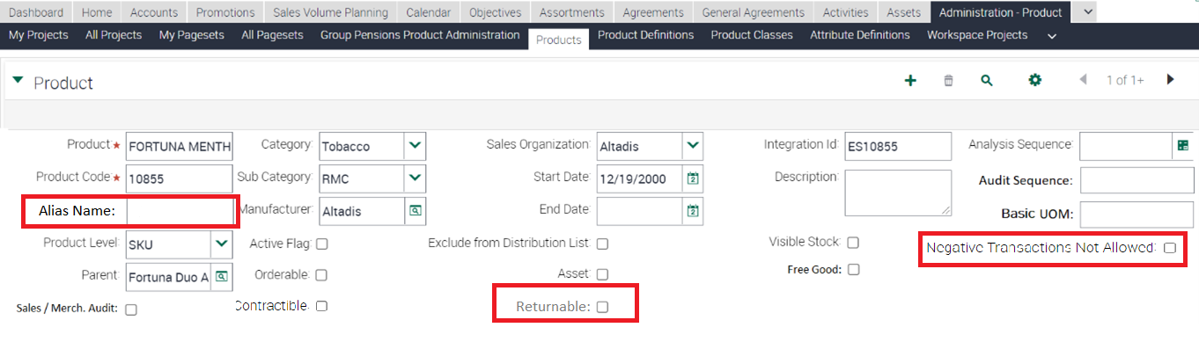

See table with the attributes included in the applet composer. Impact on V1(IT, ES; CZ, SK, HU), V2 (IE, KZ) and V3 (RU) markets.

| **Attribute** | **Display Value** | **Table** | **Column** | **Type** | **Action** |
| --- | --- | --- | --- | --- | --- |
| Alias Name | Alias Name | S_PROD_INT | ALIAS_NAME | Text | Displayed. Editable |
| Return if Defective | Returnable | S_PROD_INT | RTRN_DEFECTIVE_FLG | Checkbox | Displayed. Editable |
| JTI Negative Stock Flag | Negative Transactions Not Allowed | S_PROD_INT | X_NEGATIVE_STOCK_FLG | Checkbox | Displayed. Editable |

Please, apply same changes as well to the Applet “Product Form Applet”.

Please, at the existing form applet, include the attributes listed in the table.

Screen: ISS Unified Administration Screen

Views: Product Administration Detail View

Business Object: Admin ISS Product Definition

Applets: JTI Product Form Applet More Info

Business Components: Internal Product - ISS Admin

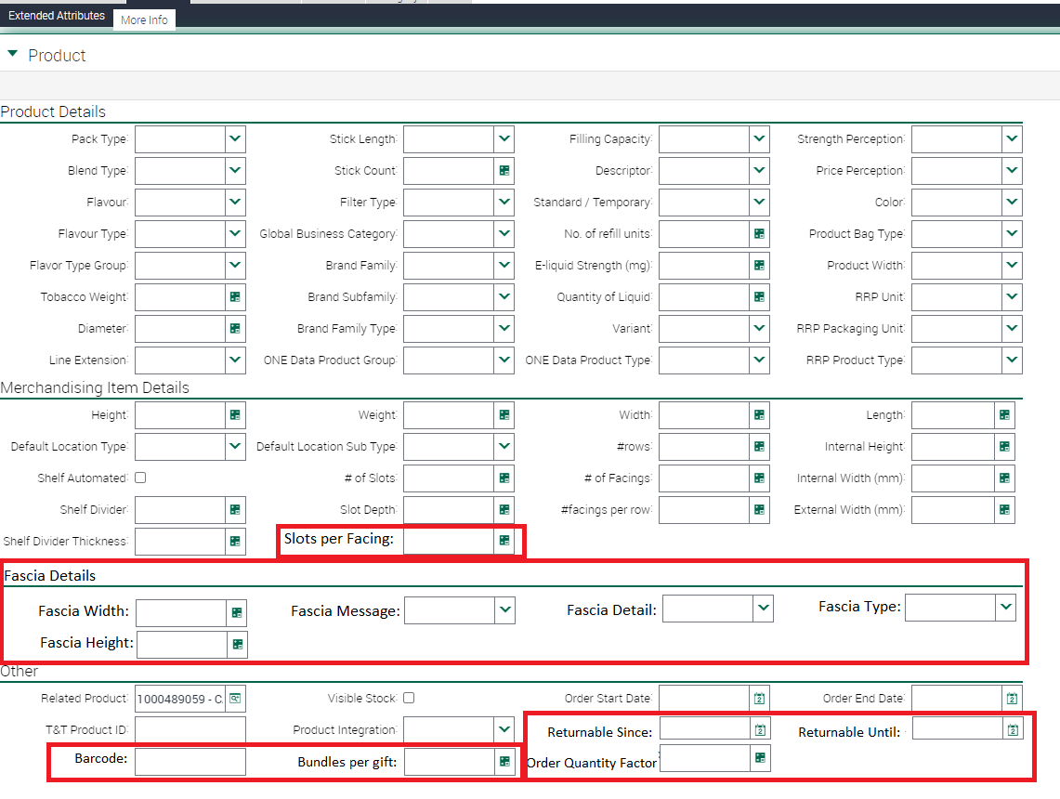

| **Attribute** | **Display Value** | **Table** | **Column** | **Type** | **Action** |
| --- | --- | --- | --- | --- | --- |
| JTI Slots per facing | Slots per Facing | S_PROD_INT | X_SLOTS_FACING_NUM | Number | Displayed in section “Merchandising Item Details”. Editable |
| JTI Returnable Since | Returnable Since | S_PROD_INT | X_RETURN_STRT_DT | Date | Displayed in section “Other”. Editable |
| JTI Returnable Until | Returnable Until | S_PROD_INT | X_RETURN_END_DT | Date | Displayed in section “Other”. Editable |
| Product Reference Id | Barcode | S_PROD_INT | BAR_CODE_NUM | Text | Displayed in section “Other”. Editable |
| JTI Gift Product Factor | Bundles per gift | S_PROD_INT | X_GIFT_FACTOR | Number | Displayed in section “Other”. Editable |
| JTI Order Quantity Factor | Order Quantity Factor | S_PROD_INT | X_ORDER_QTY_FACT | Number | Displayed in section “Other”. Editable |
| GAL ME Fascia Width | Fascia Width | S_PROD_INT | X_ME_FASCIA_WIDTH | Number | Displayed in new section “Fascia Details”. Editable |
| GAL ME Fascia Message | Fascia Message | S_PROD_INT | X_ME_FASCIA_MESSAGE | Picklist | Displayed in new section “Fascia Details”. Editable |
| GAL ME Fascia Detail | Fascia Detail | S_PROD_INT | X_ME_FASCIA_DETAIL | Picklist | Displayed in new section “Fascia Details”. Editable |
| GAL ME Fascia Type | Fascia Type | S_PROD_INT | X_ME_FASCIA_TYPE | Picklist | Displayed in new section “Fascia Details”. Editable |
| GAL ME Fascia Height | Fascia Height | S_PROD_INT | X_ME_FASCIA_HEIGHT | Number | Displayed in new section “Fascia Details”. Editable |

This applet should be activated for V1(IT, ES; CZ, SK, HU) and V2/V3(IE,KZ and cluster, RU) Markets according to roll-out activities for each Market. This could be managed according to either a new Market setting or according to the defined approach for the rest of the Markets. It should be possible to change this setup at any point of time.

**Nice to have**. The Markets should be able to tailor each section in order to show / visualize only those attributes that are relevant according to their process definition. For instance, that through applet composer we could have the possibility to define the section on top of list of attributes.

## Changes related to UOM

Please, add next restriction to the Product entity: once the product it is published at the catalogue and active, the attribute “JTI Basic UOM” cannot be modified from one existing value to another.

Please, activate functionality of UOM related at the **CHG212558 – TMEC MD Product Unit of Measure** to the markets in V2 & V3 (IE, KZ, RU).

## English Captions

|  |  |  |  |  |
| --- | --- | --- | --- | --- |
| Type | Format | Caption ENU | Language | Caption LOCAL |
| Field: JTI Returnable Since | Date | Returnable Since | ENU | TBD |
| Field: JTI Returnable Since | Date | Returnable Since | EIR | TBD |
| Field: JTI Returnable Since | Date | Returnable Since | KZA | TBD |
| Field: JTI Returnable Until | Date | Returnable Until | ENU | TBD |
| Field: JTI Returnable Until | Date | Returnable Until | EIR | TBD |
| Field: JTI Returnable Until | Date | Returnable Until | KZA | TBD |

## Changes in the ETL

* *Functionally explain the general ETL requirements, listing in the below table all the fields required to be moved to OLAP, using ENU labels if coming from Sales Application views.*
* *If not present already in the TME Sales section, application print screens are required.*
* *Hidden fields technically needed by the ETL (e.g., Ids, Foreign Keys) do not have to be listed down*
* *It is however crucial that all fields functionally required are listed and that help is offered for Technical Teams to derive the correct implementation in terms of transformation/logic.*
  + *Please clarify needed transformations (IF NULL SET to 0) or calculations (complex logic)*
  + *Any filtering required at extraction or inserting time.*
* *Kindly combine the info in the below table with written requirements to clarify the requirements.*

Next attributes must be included on the ETL to PBI.

|  |  |  |  |  |  |
| --- | --- | --- | --- | --- | --- |
|  | OLTP Source | | ETL | BI Target | |
| # | **Entity** | **Attribute** | **Transformation** | **Entity** | **Attribute** |
| 1 | Product | Alias Name | TBD | Product | Alias Name |
| 2 | Product | Return if Defective | TBD | Product | Returnable |
| 3 | Product | Product Reference Id | TBD | Product | Barcode |
| 4 | Product | GAL ME Fascia Width | TBD | Product | Fascia Width |
| 5 | Product | GAL ME Fascia Message | TBD | Product | Fascia Message |
| 6 | Product | GAL ME Fascia Detail | TBD | Product | Fascia Detail |
| 7 | Product | GAL ME Fascia Type | TBD | Product | Fascia Type |
| 8 | Product | GAL ME Fascia Height | TBD | Product | Fascia Height |
| 9 | Product | JTI Returnable Since | TBD | Product | Returnable Since |
| 10 | Product | JTI Returnable Until | TBD | Product | Returnable Until |
| 11 | Product | JTI Negative Stock Flag | TBD | Product | Negative Transactions Not Allowed |
| 12 | Product | JTI Slots per facing | TBD | Product | Slots per facing |
| 13 | Product | JTI Cost 1 | TBD | Product | Cost |
| 14 | Product | JTI Gift Product Factor | TBD | Product | Bundles per gift |
| 15 | Product | JTI Order Quantity Factor | TBD | Product | Order Quantity Factor |

## Initial Loads/Massive Data updates

* *Use the below table to specify the requirements for data updates:*
* *Please help to clarify filters by market, period, or other attribute (in the remarks column).*
* *A data update’s urgency is dependent on the fact an impacted field in the update is used in Siebel Sales or BI application logic. In case so, it will be defined as urgent, and the update will be done immediately after the technical release, ideally during the outage.*

|  |  |  |  |  |  |
| --- | --- | --- | --- | --- | --- |
| Data Update | | | | | |
| # | **Entity** | **Markets** | **Periods** | **Urgent (ODC)** | **Remarks** |
|  |  |  |  |  |  |
|  |  |  |  |  |  |

*\*In case TME Sales or BI application logic relies on the data update, this must be set as urgent.*

## Performance test/Indexes creation

* *It is assumed that ETL Performance Analysis and optimization will be done in all cases which require it, especially in brand new tables. Please note BI performance optimization is not subject of this analysis. If it applies, list down the requirements / newly developed areas that require a performance test with reasonable volume.*

## Changes in BI

*It is mandatory to include examples of the reports that are expected using the new metrics/objects that will be created. These reports are needed to validate that the technical solution will cover the requirements and later to test the development.*

* ***For new metrics****, it is needed to include an example (attached to doc).* 
  + *The steps are: create one report with existing data and include the XML; export the data to Excel and include the new metrics as fields calculated in Excel itself. The calculated fields will be used to validate the values obtained with the new metrics in DEV and UAT.*
  + *If the new metric requested can currently be calculated in the report, it is also useful to have the current formula included in the report for validation.*
  + *Also see an example copied at the end of this email where the new columns were added as literals in the report to show where they would be.*
* ***For new fact tables and/or dimensions****, it is needed to specify which other existing fact tables and dimensions are expected to be used together with the new objects. This is what we call “cross fact analysis”.* 
  + *Example: new Fact – Contracted Vending Machine Compliance. Market could require mixing this new fact with Fact – Contract Vending Machine, Fact – Contract Vending Machine Labels, Fact – Contract and dimensions Contract, Label Products, etc.*
  + *This is extremely important because we can’t guarantee that the new objects will work with existing objects if this was not explicitly requested in the FD. In case the market requests new cross fact analysis later, it will be considered a new requirement and will be subject to risk analysis and release timing. If raised late or has high risk, would be left for the next release.*
* ***For new cross fact analysis related to existing objects****, it is needed to generate an example with similar format as the one attached. Create reports with the existing functionality, show the result returned currently (include XML), export it to Excel and create there the report expected after the CR implementation, putting the different pieces together.*

Next attributes must be available for reporting on PBI.

|  |  |  |  |  |  |
| --- | --- | --- | --- | --- | --- |
|  | OLTP Source | | ETL | BI Target | |
| # | **Entity** | **Attribute** | **Transformation** | **Entity** | **Attribute** |
| 1 | Product | Alias Name | TBD | Product | Alias Name |
| 2 | Product | Return if Defective | TBD | Product | Returnable |
| 3 | Product | Product Reference Id | TBD | Product | Barcode |
| 4 | Product | GAL ME Fascia Width | TBD | Product | Fascia Width |
| 5 | Product | GAL ME Fascia Message | TBD | Product | Fascia Message |
| 6 | Product | GAL ME Fascia Detail | TBD | Product | Fascia Detail |
| 7 | Product | GAL ME Fascia Type | TBD | Product | Fascia Type |
| 8 | Product | GAL ME Fascia Height | TBD | Product | Fascia Height |
| 9 | Product | JTI Returnable Since | TBD | Product | Returnable Since |
| 10 | Product | JTI Returnable Until | TBD | Product | Returnable Until |
| 11 | Product | JTI Negative Stock Flag | TBD | Product | Negative Transactions Not Allowed |
| 12 | Product | JTI Slots per facing | TBD | Product | Slots per facing |
| 13 | Product | JTI Cost 1 | TBD | Product | Cost |
| 14 | Product | JTI Gift Product Factor | TBD | Product | Bundles per gift |
| 15 | Product | JTI Order Quantity Factor | TBD | Product | Order Quantity Factor |

## Data Dictionary

*New fields in BI should be added to the Data Dictionary. Actions below should be done:*

* *Business Description of the new fields (BTS TME) must be provided in this section.*
* *Fields should be added to the Data Dictionary DB Tables (ODC)*
* *In BI, Business Description should be configured to appear when mouse is over.*

Please, include next fields in the data dictionary:

Alias Name: this is the alias of the product. It can store product name from external systems.

Returnable: if product can be returned in an order or not.

Returnable Since: start date of the return period.

Return Until: end date of the return period.

Barcode: product barcode.

Fascia Width: width of the fascia.

Fascia Message: picklist with the message on the fascia.

Fascia Detail: picklist with the details of the fascia.

Fascia Type: picklist with the type of the fascia

Fascia Height: height of the fascia.

Slots per facing: number of slots per facing.

Negative Transactions Not Allowed: flag to disable/enable negative inventory transactions of the product.

Cost: attribute to store product cost, referred for example to VM cost.

Bundles per gift: number of bundle products for a gift.

Order quantity number: number of products for an order.

## Changes in Data Interfaces

*Populate the below table with the information of the new inbound/outbound Interfaces requested, specifying:*

* *OLTP or OLAP | Entity | Interface Code*
* *Fields requested (or new fields to be added in new version)*
* *Explain the logic behind each field, if there are any remarks about its incoming format, required transformations, data type (to keep this simple, we use String, Number, Date, Datetime, Time, LOV)*
* *Add extra information about schedule (Nightly ETL, One-time, other custom schedule) in this section.*
* *For Outbound interfaces add Business Rules:* 
  + *specify the source system conditions for a record to be exported*
  + *specify the post-export actions required to set records as exported*
* *Repeat this information for each interface, do not mix requirements.*
* *Combine the info in the below table with written requirements to clarify the requirements.*
* *Ensure you add a note in FD in case a new OLTP Interface may have impact in Siebel Remote Transaction Backlog, so that Technical Teams consider the risk in the design. Anything that will massively update or insert in OLTP is a risk for Transaction Backlog. As well, please consider a massive execution of the new process in the Use Case section, as this will be replicated in the CHG’s Test Script.*

## Inbound

Next attributes have to be included in the Product inbound interface (PR) as optional fields (not mandatory).

|  |  |  |  |  |  |  |
| --- | --- | --- | --- | --- | --- | --- |
| *OLTP Product Inbound - PR* | | | | | | |
| **#** | **Entity** | **Field Name** | **Contents** | **Data type / format** | **Table.Column** | **Transformation** |
| 1 | Product | Product Reference Id | Barcode  Barcode of the product | Text (50) | *S_PROD_INT.* *BAR_CODE_NUM* | *Add to the interface.* |
| 2 | Product | GAL ME Internal Width | Internal width (mm)  Refers to the internal width of the Merchandising Equipment | Number | *S_PROD_INT.* *X_ME_EXTERNAL_WIDTH* | *Add to the interface.* |
| 3 | Product | GAL ME External Width | External width (mm)  Refers to the external width of the Merchandising Equipment | Number | *S_PROD_INT.* *X_ME_INTERNAL_WIDTH* | *Add to the interface.* |
| 4 | Product | Internal Height | Internal Height  Refers to the internal height of the Merchandising Equipment | Number | *S_PROD_INT.* *X_INT_HEIGHT_NUM* | *Add to the interface.* |
| 5 | Product | GAL ME Fascia Width | Fascia Width  Refers to the fascia width | Number | *S_PROD_INT.* *X_ME_FASCIA_WIDTH* | *Add to the interface.* |
| 6 | Product | GAL ME Fascia Message | Fascia Message  Refers to the fascia message | Picklist GAL_ME_FASCIA_MESSAGE | *S_PROD_INT.* *X_ME_FASCIA_MESSAGE* | *Add to the interface.* |
| 7 | Product | GAL ME Fascia Detail | Fascia Detail  Refers to the fascia detail | Picklist GAL_ME_FASCIA_DETAIL | *S_PROD_INT.* *X_ME_FASCIA_DETAIL* | *Add to the interface.* |
| 8 | Product | GAL ME Fascia Type | Fascia Type  Refers to the fascia type | Picklist GAL_ME_FASCIA_TYPE | *S_PROD_INT.* *X_ME_FASCIA_TYPE* | *Add to the interface.* |
| 9 | Product | GAL ME Fascia Height | Fascia Height  Refers to the fascia height | Number | *S_PROD_INT.* *X_ME_FASCIA_HEIGHT* | *Add to the interface.* |
| 10 | Product | JTI Default Location Sub Type | Default Location Sub Type  Refers to the Location Sub Type of the Merchandising Equipment | Picklist JTI_LOC_SUB_TYPE | *S_PROD_INT.* *X_DEF_LOC_SUB_TYPE_CD* | *Add to the interface.* |
| 11 | Product | JTI Shelf Automated | Shelf Automated  Flag to indicate automated shelf | Boolean | *S_PROD_INT.* *X_SHELF_AUTOMATED_ FLG* | *Add to the interface.* |
| 12 | Product | JTI Shelf Divider | Shelf Divider  Number of shelf dividers in the Merchandising Equipment | Number | *S_PROD_INT.* *X_SHELF_DIVIDER_NUM* | *Add to the interface.* |
| 13 | Product | JTI Slot Depth | Slot Depth  Depth of the slot in the Merchandising Equipment | Number | *S_PROD_INT.* *X_SLOT_DEPTH_NUM* | *Add to the interface.* |
| 14 | Product | JTI Shelf Divider Thickness | Shelf Divider Thickness  Thickness of the shelf divider for the Merchandising Equipment | Number | *S_PROD_INT.* *X_SHELF_DIV_THICK_NUM* | *Add to the interface.* |
| 15 | Product | JTI Rows | # of rows  Number of rows in the Merchandising Equipment | Number | *S_PROD_INT.* *X_ROWS_NUM* | *Add to the interface.* |
| 16 | Product | JTI Facings per row | # of Facings per row  Number of facings per row in the Merchandising Equipment | Number | *S_PROD_INT.* *X_FACING_ROW_NUM* | *Add to the interface.* |
| 17 | Product | JTI Facings Nr | # of Facings  Number of facings in the Merchandising Equipment | Number | *S_PROD_INT.* *X_FACINGS_NUM* | *Add to the interface.* |
| 18 | Product | JTI Orderable Start Date | Orderable Since  Refers to date range in which a Product could be orderable | Date | *S_PROD_INT.* *X_ORDERABLE_ START_DT* | *Add to the interface.* |
| 19 | Product | JTI Orderable End Date | Orderable Until  Refers to date range in which a Product could be orderable | Date | *S_PROD_INT.* *X_ORDERABLE_ END_DT* | *Add to the interface.* |
| 20 | Product | JTI Returnable Since | Returnable Since  Refers to date range in which a Product could be returned (related to order process) | Date | *S_PROD_INT.* *X_RETURN_STRT_DT* | *Add to the interface.* |
| 21 | Product | JTI Returnable Until | Returnable Until  Refers to date range in which a Product could be returned (related to order process) | Date | *S_PROD_INT.* *X_RETURN_END_DT* | *Add to the interface.* |
| 22 | Product | JTI DL Contractible Flg | DL Contractible  This field is used to mark which products can be in the distribution list for a contract item. E.g.: can be selected at the Assortment condition. | Boolean | *S_PROD_INT.* *X_DL_CONTRACTIBLE_FLG* | *Add to the interface.* |
| 23 | Product | JTI Slots per facing | Slots per Facing  Number of slots per facing in the Merchandising Equipment | Number | *S_PROD_INT.* *X_SLOTS_FACING_NUM* | *Add to the interface.* |
| 24 | Product | JTI Cycle Count Category | Cycle Count Category | Picklist JTI_PROD_CAT | *S_PROD_INT.* *X_COUNT_CLASS* | *Add to the interface.* |
| 25 | Product | JTI Gift Product Factor | Bundles per gift | Number | *S_PROD_INT.* *X_GIFT_FACTOR* | *Add to the interface.* |
| 26 | Product | JTI Order Quantity Factor | Order Quantity Factor | Number | *S_PROD_INT.* *X_ORDER_QTY_FACT* | *Add to the interface.* |
| # |  |  |  |  |  |  |

## Outbound

|  |  |  |  |  |  |  |
| --- | --- | --- | --- | --- | --- | --- |
| *N/A* | | | | | | |
| # | **Entity** | **Field Name** | **Contents** | **Data type/format** | | **Transformation** |
| 1 |  |  |  |  | *Explain any required modification of the exported data* | |
| # |  |  |  |  |  | |

## Initial Loads

*Specify requirements for initial data loads if required.*

## Performance test / Indexes creation

*Specify requirements for performance test or indexes creation if required.*

## Changes in Batch Processes / Aggregations / DRP

*This section will be used for specifying requirements different to pure ETL tasks or Inbound or Outbound interfaces. It is assumed that these processes are not trivial and require transforming data in a complex way. Therefore, functionality will be explained by means of*

* *List of written requirements, in case requirements are not too complex and their written specification is not vague*
* *Pseudo-code / basic flowchart diagram (available in every Visio installation)*
* *A combination of both*
* *Always using ENU Names of TME Sales or BI application fields and agreed entity names as per TME ENU application or OBIEE subject areas.*
* *Please ensure you add a note in FD in case a new OLTP Batch may have impact in Siebel Remote Transaction Backlog, so that Technical Teams consider the risk in the design. Anything that will massively update or insert in OLTP is a risk for Transaction Backlog. As well, please consider a massive execution of the new process in the Use Case section, as this will be replicated in the CHG’s Test Script.*

## Use Case

|  |  |  |
| --- | --- | --- |
| Role  *Trade Marketer, ASM, Local Admin…* | Application  *Sales, Analytics, ETL, Batch, Interface* | Step  *Description of the step and its expected output* |
| Local Admin | Siebel Sales/BI | Populate the new fields manually.  Check that the fields are correctly displayed in the list and form applets for product.  Check that the appropriate data has been generated in OLTP.   Wait for Nightly ETL. Validate that the field is transferred to BI |
| Local Admin | Interface | Prepare a flat file following the PR interface naming and format definition, including values for the attributes added to the interface.  Place the file at the server IUNP folder (SSIS console).  Check that the file is automatically processed during night and the data is available in Siebel and after ETL also in PBI. |
|  |  |  |